Week3
July 2025
#install.packages("ggplot2")
library(ggplot2)

BACKGROUND
In this activity you will consider the usefulness of some suggested R code, identify data issues, and produce descriptive statistics.
A researcher is interested in the heights and weights of a population of adults, and whether these differ according to whether the adult has an active lifestyle or not and whether adults are left or right-handed. In general, they are interested in any interesting findings that can be found by exploring the dataset.

SUPPORT
There is a supporting video that introduces this exercise, that uses the same data structure but different sample values. This may help you understand the context.
Watch this video on YouTube

LOADING THE DATA
Load the dataset here! Call the dataset ‘content’.
This approach assumes that you have a directory structure with subfolders called ‘data’ and ‘scripts’. The data should be in the ‘data’ folder, and the Rmarkdown file should be saved in the ‘scripts’ folder. This is standard industry good practice for file directory structure. It helps towards the principles of reproducible research if we all follow the same directory structure anyone can run your code.
content <- read.csv("../data/weight_height.csv")

DATA STRUCTURE
str(content)
## 'data.frame': 1412 obs. of 4 variables:
## $ weight: num 79.8 79.6 77.2 82.1 82.3 ...
## $ height: num 176 179 178 181 180 ...
## $ active: chr "no" "yes" "yes" "no" ...
## $ handed: chr "right" "left" "right" "left" ...
The variables collected for a number of adults are: weight – in kilograms height – in centimetres handed - if adult is ‘left’ or right’ handed active - is adult considered to be active? ‘yes’ or ‘no’

Helpful Code
Some useful code is given below. Try it out and see what it does.
summary(content)
## weight height active handed
## Min. :11.00 Min. : 0.0 Length:1412 Length:1412
## 1st Qu.:77.25 1st Qu.: 175.6 Class :character Class :character
## Median :79.82 Median : 178.5 Mode :character Mode :character
## Mean :79.68 Mean : 179.8
## 3rd Qu.:82.21 3rd Qu.: 181.6
## Max. :92.89 Max. :1792.4
# Summary of numeric columns
summary(content[, sapply(content, is.numeric)], na.rm = TRUE)
## weight height
## Min. :11.00 Min. : 0.0
## 1st Qu.:77.25 1st Qu.: 175.6
## Median :79.82 Median : 178.5
## Mean :79.68 Mean : 179.8
## 3rd Qu.:82.21 3rd Qu.: 181.6
## Max. :92.89 Max. :1792.4
# Summary of numeric columns
#summary(content[, sapply(content, is.numeric)], na.rm = TRUE)
# Frequency tables
table(content$handed)
##
## left right unknown
## 85 1320 7
table(content$handed, content$active)
##
## missing no unknown yes
## left 0 55 4 26
## right 2 997 51 270
## unknown 0 6 0 1
# Mosaic plot
mosaicplot(table(content$handed, content$active))
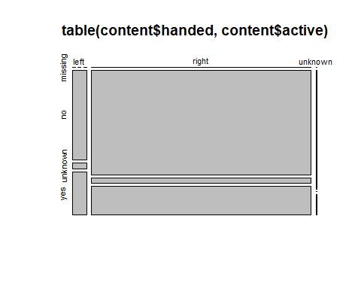
# Summary statistics by handedness
by(content, factor(content$handed), summary)
## factor(content$handed): left
## weight height active handed
## Min. :71.10 Min. :168.1 Length:85 Length:85
## 1st Qu.:76.91 1st Qu.:176.3 Class :character Class :character
## Median :79.14 Median :178.5 Mode :character Mode :character
## Mean :79.36 Mean :178.3
## 3rd Qu.:82.00 3rd Qu.:181.2
## Max. :92.49 Max. :186.4
## ------------------------------------------------------------
## factor(content$handed): right
## weight height active handed
## Min. :11.00 Min. : 0.0 Length:1320 Length:1320
## 1st Qu.:77.28 1st Qu.: 175.6 Class :character Class :character
## Median :79.86 Median : 178.6 Mode :character Mode :character
## Mean :79.70 Mean : 180.0
## 3rd Qu.:82.22 3rd Qu.: 181.6
## Max. :92.89 Max. :1792.4
## ------------------------------------------------------------
## factor(content$handed): unknown
## weight height active handed
## Min. :76.78 Min. : 2.0 Length:7 Length:7
## 1st Qu.:77.19 1st Qu.:170.0 Class :character Class :character
## Median :80.21 Median :173.1 Mode :character Mode :character
## Mean :79.88 Mean :149.0
## 3rd Qu.:81.94 3rd Qu.:175.6
## Max. :83.91 Max. :176.8
# Proportions of handedness
prop.table(table(content$handed))
##
## left right unknown
## 0.060198300 0.934844193 0.004957507
# Replace "unknown" with NA in 'handed'
content$handed[content$handed == 'unknown'] <- NA
# Replace extreme weight values with NA
content$weight[content$weight > 250] <- NA
# Count of non-missing weight values
length(na.omit(content$weight))
## [1] 1412
# Aggregated height statistics by handedness and activity
agg<- aggregate(
height ~ handed + active,
data = content,
FUN = function(x) c(mean = mean(x), sd = sd(x))
)

Preliminary exploratory data analyses.
Adapting the above code, or otherwise, prepare some summary statistics for the attached data.
Consider what this reveals about any issues with the raw data, and further data preparation that may be required prior to statistical analyses. List those issues here.
str(content)
## 'data.frame': 1412 obs. of 4 variables:
## $ weight: num 79.8 79.6 77.2 82.1 82.3 ...
## $ height: num 176 179 178 181 180 ...
## $ active: chr "no" "yes" "yes" "no" ...
## $ handed: chr "right" "left" "right" "left" ...
summary (content)
## weight height active handed
## Min. :11.00 Min. : 0.0 Length:1412 Length:1412
## 1st Qu.:77.25 1st Qu.: 175.6 Class :character Class :character
## Median :79.82 Median : 178.5 Mode :character Mode :character
## Mean :79.68 Mean : 179.8
## 3rd Qu.:82.21 3rd Qu.: 181.6
## Max. :92.89 Max. :1792.4
Here’s a concise summary of the key insights from your statistics:
Weight: Values are fairly consistent, centered around ~80, with no obvious outliers. Distribution looks reasonable.
Height: Most values are realistic (around 175–182), but there is a major outlier (1792.4), which is likely a data entry error and should be investigated or removed.
Active & Handed: Both are stored as character variables, indicating categorical data that should ideally be converted to factors for proper analysis.
#boxplot to visualise the outlier or anomalies in the height
ggplot(content, aes(y=height)) + geom_boxplot()+
labs(
y = "height",
title= "Distribution of height"
)+
theme_minimal()
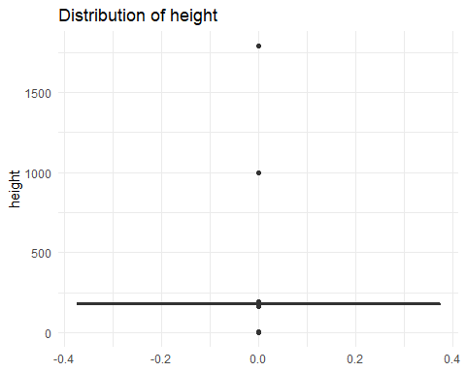
#boxplot to visualise the outlier or anomalies in the height
ggplot(content, aes(y=weight)) + geom_boxplot()+
labs(
y = "weight",
title= "Distribution of weight"
)+
theme_minimal()
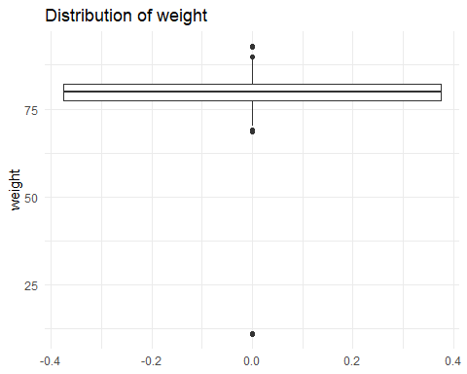 # Key insight
There are extreme outliers (around approximately 1000 and approximately 1790), which are clearly unrealistic.
These outliers stretch the scale, making the main data look compressed.
# Frequency tables
table(content$handed)
##
## left right
## 85 1320
# proportional Frequency tables
prop.table(table(content$handed))
##
## left right
## 0.06049822 0.93950178
table(content$handed, content$active)
##
## missing no unknown yes
## left 0 55 4 26
## right 2 997 51 270
#mosaic plot to visually represent handedness by active
mosaicplot(table(content$handed, content$active))
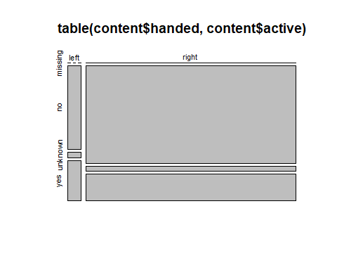
# Count of non-missing weight values
length(is.na(content$weight))
## [1] 1412
# Count of non-missing weight values
length(is.na(content$height))
## [1] 1412

Data Cleaning
Apply any further data preparation that may be required prior to statistical analyses, to ensure that only valid observations will be included in future analyses.
# replace extreme weight values with NA
content$weight[content$weight < 25] <- NA
# # replace extreme height values with NA
content$height[content$height < 25] <- NA
# replace extreme height values with NA
content$height[content$height < 140 | content$height > 220] <- NA
# replace missing value
content$handed[content$handed == "right" ] <- NA
# handling low frequency groups
content$handed[content$handed == "unknown"] <- NA
#check total values of NA
sum(is.na(content))
## [1] 1336
#boxplot to confirm the outlier or anomalies in the height have been removed
ggplot(content, aes(y=height)) + geom_boxplot()+
labs(
y = "height",
title= "Distribution of height"
)+
theme_minimal()
## Warning: Removed 6 rows containing non-finite outside the scale range
## (`stat_boxplot()`).
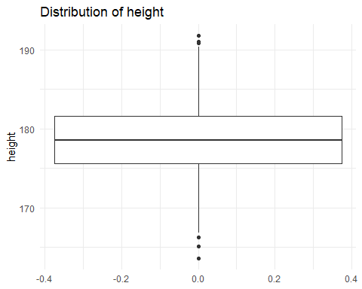
#boxplot to confirm the outlier or anomalies in the weight have been removed
ggplot(content, aes(y=weight)) + geom_boxplot()+
labs(
y = "weight",
title= "Distribution of weight"
)+
theme_minimal()
## Warning: Removed 3 rows containing non-finite outside the scale range
## (`stat_boxplot()`).
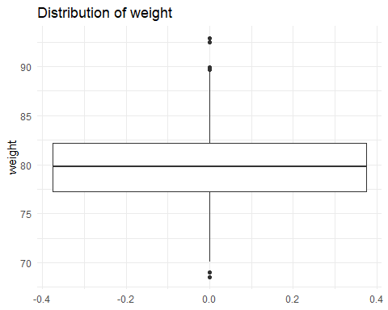 ## Exploratory data analyses using only the valid observations.
Produce summary statistics using only the valid observations. You may wish to consider for example:
How many adults in the sample are active?
What is the best estimate for the proportion of adults in the population that are active?
How many active adults in the sample are right-handed?
How many valid observations are there for weight?
What is the sample minimum weight?
What is the sample maximum weight?
What is the sample mean weight?
What is the sample standard deviation for weight?
What is the sample minimum weight of the active adults?
What is the sample maximum weight of the active adults?
What is the sample mean weight of the active adults?
What is the sample standard deviation weight of the active adults?

Conclusions
Offer some interpretation. Some examples of research questions you may want to answer are:
How do active adults compare to non-active adults in terms of weight and height?
How does the average and variability of weight and height differ by handedness?

